Goal:

Use crude oil export data from varying western countries and Russia to create a model to predict impact the invasion of Ukraine has on other countries land-use for drilling oil.

Relevance / Why we care:

With the most recent invasion of the Ukraine, a lot of fingers can be pointed to Russia’s leverage of their exportation of oil as protection from international intervention in times of political aggression and how other large land area countries may have to designate a greater percentage of land use to counter-act this leverage.

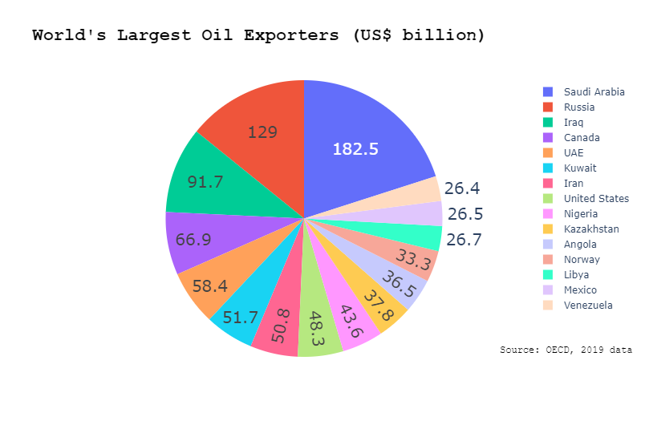

Questions answered:

1. Primary

- Quantify impact of Russian oil exportation and economic situation on other counties own exportation of oil.

Use the model that we develop to then project future exportation increases by other countries namely those in the west that have large land-masses i.e. Canada, United States, Norway.

2. Secondary:

- Quantify threat that Russian wartime economic increase/decrease has on western countries use of land for oil harvesting practices.

Potential datasets :

1. <https://www.kaggle.com/nitishabharathi/the-shrinkage-of-crude-oil-price> (simple spread of oil exportation percentage globally)
2. <https://datasource.kapsarc.org/explore/dataset/total-proved-oil-reserves-thousand-millions-barrels-1995-2015/information/?disjunctive.total_proved_reserves> (proved oil reserves data set)
3. <https://www.ceicdata.com/en/indicator/russia/crude-oil-exports> (Data detailing Russian crude oil exports)
4. <https://www.cer-rec.gc.ca/en/data-analysis/canada-energy-future/2021conventional/index.html> (projected future oil production by Canada by province)
5. <https://www.norskpetroleum.no/en/production-and-exports/exports-of-oil-and-gas/> (Norwegian oil data)
6. <https://www.eia.gov/dnav/pet/hist/LeafHandler.ashx?n=PET&s=MCREXUS2&f=M> (USA)